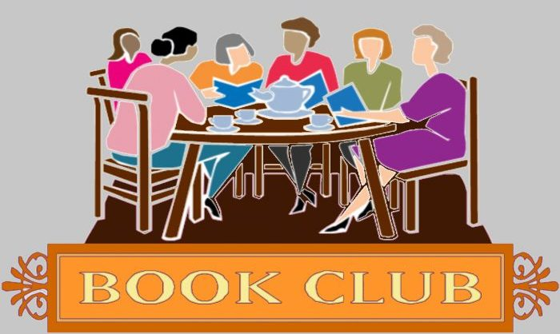
FRIENDS OF THE FLAT ROCK PUBLIC LIBRARY
BOOK CLUB
2022-2023
1ST SATURDAY OF THE MONTH at 11:00 A.M.
(in the library activity room)
August 6: The Lincoln Highway by Amor Towles
**September 10: Hotel on the Corner
of Bitter and Sweet by Jamie Ford
October 1: The Graveyard Book by Neil Gaiman
November 26: Ordinary Grace by Wm. Kent Krueger
December 3: Hercule Poirot’s Christmas by Agatha Christie
**January 7: Annie’s Ghost: A Journey into a Family Secret by Steve Luxenberg
**Due to Holiday, Book Club Date pushed to second week
For more information contact the library:
@ 734-782-2430 or FlatRockLibrary@gmail.com

